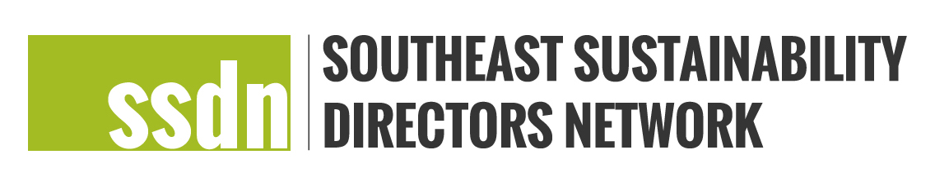

SSDN Peer Learning Charrette Report Template

Please complete and submit this report no later than March 1, 2020 and submit to Meg Jamison, meg@southeastsdn.org. Reports should be between 2-3 pages and should be submitted by the lead applicant and/or host.

- Lead applicant name, city/county, state:
- Peer Learning Charrette title and grant code:
- Peer learning charrette participant counties/cities (please list all who plan to participate):
- Location of exchange:
- Please explain the results of your charrette. Highlight specific elements related to sustainability, equity, resilience, adaptation, mitigation and/or other areas that have been focused on during this charrette:
- What were some key lessons learned?
- What are the opportunities for future collaborative work (if applicable)?
- Was the exchange successful? How did you measure success?
- Please include a budget report of expenses incurred as related to the approved budget:
- Please include or attach the final agenda and any other related materials from the exchange:

Individual Participant Reflections

Every participating city should submit a ½ to 1 page response to the following questions:
- Participant Name and Jurisdiction:
- Peer Learning Charrette Title:
- Did you learn a new idea through this charrette? What did you learn?
- How will you be able to leverage what you learned? How will you apply it to your work?
- How can the SSDN network leverage the work from this charrette?

