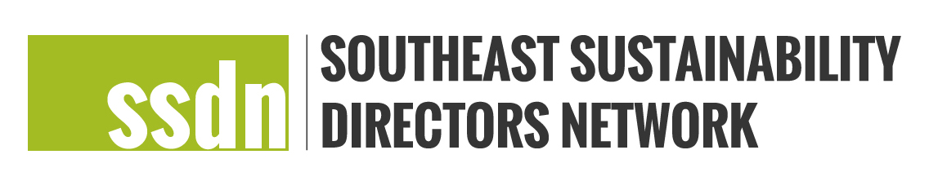
SSDN Peer Learning Charrette Application Template

Please complete this application and submit to Meg Jamison, meg@southeastsdn.org. Please submit applications in Microsoft Word format, with 11 point font minimum, and no more than 4 pages. Applications must include the following:

- Applicant name, city/county, state.
- Peer learning charrette participants, role, counties/cities, year joined (please list all who plan to participate and explain the reason they were chosen to participate).
- Location and date of exchange (this can be general if exact details are not known).
- Budget request (include total amount requested and justification for funding going to third parties like facilitators, etc.).
- What is the need for this charrette?
- Topics to be explored, discussed and how participants will work to advance priorities and/or work related to the topic. Please highlight specific elements related to sustainability, equity, resilience, adaptation, mitigation and/or other areas that will be focused on during the charrette.
- What are the goals and the desired outcome of the charrette? Please share potential benefits to cities, any mentorship opportunities and any opportunity for future work.
- Meeting preparation: How have and will members be engaged in the planning and preparation for the charrette?
- Meeting plan and/or agenda: Please include a plan for the meeting and/or an agenda that is detailed with as much specificity as possible.
- How will you incorporate learning opportunities for members in all stages of their sustainability work? What are the opportunities for mentorship?
- Please include a budget (SSDN cannot accept budget proposals over $5,000):
- Please sign the commitment below to reduce the carbon footprint of this charrette.

As the lead applicant, on behalf of meeting participants, I confirm that our charrette will strive to minimize the carbon footprint of the meeting in any way possible.

Name:
Signed:
Date:

